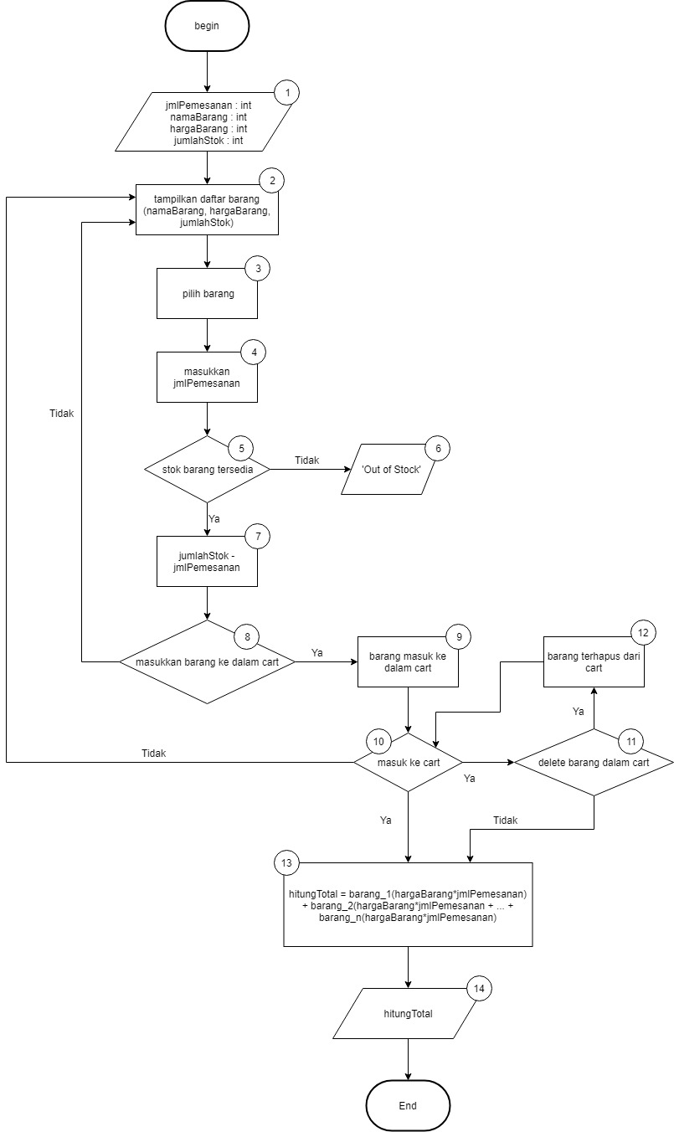

Cyclomatic Complexity = decision + 1 = 3 + 1 = 4

Test Case :

1-2-3-4-5-6

1-2-3-4-5-7-8-2-3-4-5-6

1-2-3-4-5-6-7-8-9-10-13-14

1-2-3-4-5-7-8-2-3-4-5-7-8-9-10-13-14

1-2-3-4-5-7-8-9-10-2-3-4-5-6

1-2-3-4-5-7-8-9-10-2-3-4-5-7-8-9-10-13-14

1-2-3-4-5-7-8-9-10-11-12-10-13-14

1-2-3-4-5-7-8-9-10-11-12-10-2-3-4-5-6

1-2-3-4-5-7-8-9-10-11-12-10-2-3-4-5-7-8-9-10-13-14

1-2-3-4-5-7-8-9-10-11-13-14

1-2-3-4-5-7-8-9-10-2-3-4-5-7-8-9-10-11-12-13-14

1-2-3-4-5-7-8-9-10-2-3-4-5-7-8-9-10-13-14

1-2-3-4-5-7-8-9-10-2-3-4-5-7-8-9-10-11-13-14